**MODULE: TTCBR**

**107**

**-**

**REFLECTION ON**

**LEARNING PROCESS**

**Competence:**

**Reflect o**

**n Learning Process**

**Learning Hours: 30**

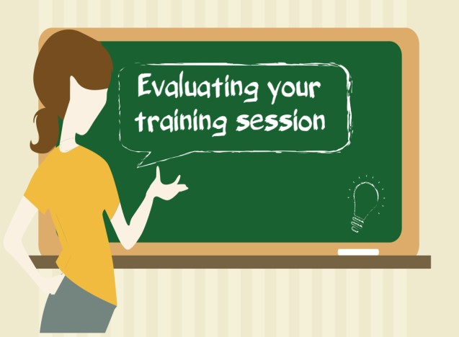

This module aims at equipping the learner with skills, knowledge and attitudes required to evaluate

the session in an interactive manner with the learners in line

with CBET approach and to identify

areas for improvement based on the evaluation results.

By the end of this module, the learner will be able to reflect on facilitation process and improve

future

sessions.

This training manual contains the content that w

ill help and guide you while

deliver

ing. It has three learning unit

s.

**1.**

**LU1**

**Describe strategies**

**to reflect on session facilitation**

**process**

**2.**

**LU2**

**Reflect**

**on**

**the session in an interactive manner with the learners in line with**

**CBET approach**

**3.**

**LU3 Improve the lea**

**rning process**

**based on the evaluation results.**

**Table of Contents**

LU1. Describe strategies to reflect on session facilitation process 3

LO 1.1.: Describe the importance of reflecting on the session facilitation process 3

LO 1.2.: Describe strategies to reflect on the session facilitation process 6

LO 1.3.: Review of Kolb Cycle stages relating to the facilitation process 13

LU2 Reflect on the session in an interactive manner with the learners in line with CBET approach 16

LO 2.1.: Review on Competency Based Education and Training (CBET)

approach 16

LO 2.2.: Identify aspect of needing improvement 19

LO 2.3.: Fill up forms to reflect on the session facilitation process in line with CBET approach 24

LU3 Improve the learning process based on the evaluation results 38

LO 3.1.: Identify strategies of improving the learning process 38

LO 3.2.: Engage in continuing professional development (CPD) 41

LO 3.3.: Set an improvement progress map 45

Reference 49

# LU1. Describe strategies to reflect on session facilitation process

Learning unit 1 describesstrategies to reflect on session facilitation process. It has three learning outcomes:

## LO 1.1.: Describe the importance of reflecting on the session facilitation process

## LO 1.2.: Describe strategies to reflect on the session facilitation process

LO 1.3.: Review of Kolb Cycle stages relating to the facilitation process



**LO 1.1.: Describe the importance of reflecting on the session facilitation process**

**Topic 1: Reflection on the session facilitation**

**Definition**

* Reflection on session facilitation is a systematic process of collecting, analyzing and interpreting information to determine the extent to which the session facilitation contributes to the achievement of learning objectives basing on facilitator’s activities. It helps a trainer to ascertain the traineeprogress from time to time.
* At the end of a topic or unit or segment or a chapter the trainer can evaluate the learning outcomes basing on which s/he can modify his/her methods, techniques and devices to provide better learning experiences.
* The trainer can even modify the learning objectives, if necessary.
* The trainer can know which aspects of the learning task were mastered and which aspects were poorly or not at all mastered by learners.

**Reasons to reflect on the facilitation process**

* Assessment of the relevance and appropriateness of the learning experiences provided and to assess instantly how far the goals are being fulfilled
* Determining the effectiveness of the session in order to improve learning process.
  + The origin of the word "effective" stems from the Latin word

effectīvus, which means **creative**, **productive** or **effective**.

* + Effectiveness measures how well the performance is
  + Effectiveness is a criterion used to assess changes determined in its behavior, capability, or assets, tied to the attainment of an end state, achievement of an objective, or creation of an effect.
* Getting experience of past learning process.
  + For example, we may want to know which parts of the session were successful and which not, or whether the approach to the session should be changed.
  + We can use these lessons learned to improve plans for future sessions.

**The advantages of evaluating the learning process**

Evaluation is a continuous process and a periodic exercise.

* It helps one to take decisions about success in specific future activities and provides guidance to further studies and occupation.
* It plays an effective role in questioning or challenging the objectives

* It helps trainers and learners to improve session facilitation and learning.
* Besides this, it is very useful to bring improvement in session and curriculum.

**Session:** Evaluation is concerned with reflecting on the effectiveness of session, session strategies, facilitation methods and techniques, development of session materials. It provides feedback to the trainer about the session and to the learners about their learning.

**Curriculum:** The improvement in sessions/curricula, texts and session materials is brought about with the help of evaluation.

.

**LO 1.2.: Describe strategies to reflect on the session facilitation process**

**Topic: Discussion on strategies to reflect on the session facilitation process**

* + The reflection on session facilitation is used to monitor the learning progress of trainees during the period of session.
  + Its main objective is to provide continuous feedback to both trainer and trainee concerning learning successes and failures while session is in process.
    - Feedback to trainees provides reinforcement of successful learning and identifies the specific learning errors that need correction from time to time.
    - Feedback to trainer provides information for modifying session and for prescribing group and individual remedial work.
    - Thus, it aims at improvement of session.

* + This type of reflection is an essential tool to provide feedback to the learners for improvement of their self-learning
  + And to the trainers for improvement of their methodologies of facilitating, nature of session materials, etc.

**Strategies and methods Strategies:**

* 1. Self-evaluation: Dialogue with yourself
  2. Trainee evaluation and feedback: solicit feedback from your trainees
  3. Peer observation and review: dialogue with peers and the department
  4. Trainee assessment tasks: seek the concerns through assessment tasks (CAT: classroom assessment techniques)

**Table 1:** Strategies and methods that can help a trainer to reflect on session facilitation

|  |
| --- |
| **Strategies** |
| **a) Self-evaluation**   * Trainers evaluate their own performance as they facilitate. * Trainers should evaluate themselves while session. * After each facilitation session, trainers should ask themselves (or complete a brief self-evaluation form) on whether they have met their determined goals and objectives, and evaluate the good and the to-be-improved aspects of the |

|  |  |
| --- | --- |
| session. | |
| **b) Trainee evaluation and feedback** | |
| **Method** | Description |
| Direct  Questioning of  Trainees | * The easiest way to find out whether trainees understand what is being said is to ask them directly. But unless facilitators have developed sufficient rapport and mutual respect among the trainees in their class, they should Avoid questions or situations that could:   Make it awkward for trainees to respond e.g. “Who is lost?”  or are so generic as to lead to no responses e.g.“Are there any questions?”   * Instead, facilitators should pose questions that encourage more specific responses   Example: “How many of you understand what we are talking about?”   * Various forms of information technology, such as in-class response keypads, can facilitate asking such questions, allowing trainees to answer without fearing that they will be singled out or ridiculed by their peers if they indicate their lack of understanding. * Even better, facilitators can ask trainees to paraphrase briefly the key points or essence of a discussion. At the end of a class session, trainees can be asked individually or in pairs to write a brief summary of the main ideas presented and submit it to the facilitator (anonymously). * If this method is used, trainees should clearly understand that   the written summary is not a quiz and will not be graded. |
| Trainee Teams | Another documented approach involves asking a team of trainees to work throughout the term on continuous session evaluation   * The team members are encouraged to administer questionnaires and interview their peers about how the facilitator is or is not promoting learning. * For larger classes, a liaison committee of two to four trainees can be established that meets periodically with the facilitator to discuss difficulties or dissatisfactions. * Membership on the committee can be rotated from a list of volunteers as long as the entire class knows who the liaisons are |

|  |  |
| --- | --- |
|  | at any given time.  ✓ Alternatively, trainees who are not enrolled in a session can be hired to attend the class and offer ongoing feedback to the facilitator |
| Minute Papers and Just-in-  Time Training | • At the end of a class, facilitators can ask trainees to write for a minute or two on one of the following kinds of questions:   * “What is the most significant thing you’ve learned today?” * “What points are still not clear?” or * “What question is uppermost in your mind at the end of today’s class?” * Responses can help facilitators evaluate how well trainees are learning the material. * Trainee responses to the second and third questions also can help facilitators select and structure topics for the next class meeting. * Large numbers of such short papers can be read quickly, and a review of unclear concepts can take place at the next class meeting. * Trainees are asked to respond to one or two short questions posed by the facilitator the day before a subject is to be taught. * They submit their responses via e-mail or to a website. These responses give the facilitator a good idea of what the trainees do and do not understand about the concepts to be considered. * The facilitator can then adjust the amount of time spent on explaining the concepts, working through problems, or providing examples that will help the trainees learn and understand the concepts. |
| Trainees’  Session Notes | With trainees’ permission, facilitators can ask to borrow a set of notes.   * This technique allows trainers to see what trainees consider to be the main points presented and whether there is misinformation or confusion about various topics. * Alternatively, to ensure trainee anonymity, trainees can be asked to photocopy selected portions of their notes and submit them to the facilitator without identifying information |
| Chain Notes | * In small classes, it may be possible to pass around a piece of paper midway through a session and ask trainees to jot down the main point of what is being discussed at that moment. * The facilitator then has a listing of what trainees consider to be the key concepts discussed in that class period, which can be used. |

|  |  |
| --- | --- |
| Trainee Study  Groups | * Trainees can be encouraged to form small study groups and to send representatives to discuss any difficulties or questions with the facilitator. * Study groups provide trainees with opportunities to learn from one another, and a group may find it easier to seek assistance from the facilitator. * In turn, having group representatives rather than individual trainees approach the facilitator can reduce the amount of time required to answer repetitive questions, especially in larger classes. |
| Informal  Conversations | * Facilitators can seek feedback through informal conversations with trainees during office hours, before or after class, or through e-mail. * They can ask trainees about what has been working well or what is problematic. * Facilitators should not pose these questions to trainees in ways or at times that might force them to answer quickly. * Questions should be directed to those trainees the trainer thinks would be most likely to respond candidly. * However, informal responses from individual trainees can serve as the basis for index card questions to the entire class (discussed next). * Asking such questions based on informal conversations with trainees can also reinforce the message that the facilitator is listening to trainees and takes input from them seriously. |
| Index Cards | * Several times during the term, a facilitator can pass out index cards to trainees and ask them to respond to two questions, one on the front of the card, the other on the back. * General questions can be posed, such as:   + “What are your overall impressions of the session?”   + “What’s good about the session?”   + “Do you have any suggestions for changing the session?”  “Are there any problems?” * Alternatively, the facilitator can ask more specific questions about aspects of the session, such as   + “Are the problem sets too difficult?”   + “Is the laboratory section well connected to other aspects of the session?” * Providing prompts such as:   + “I would like you to do more…” |

|  |  |
| --- | --- |
|  | “I would like you to do less …” |
| **c) Peer observation and review** | |
| Methods | Description |
| Outside  Evaluators | * Midway through the term, a facilitator can invite an instructional improvement specialist from the discipline-based session and learning center or a departmental colleague to conduct an oral evaluation with his or her trainees. * At the beginning of the class, the trainer introduces the guest evaluator and then leaves the room for 20 minutes. * During that time, the evaluator asks trainees to cluster into groups of five or six and take 10 minutes to:   + Select a spokesperson, who will write down the group’s comments,   + Name something in the session they find very helpful or worthwhile,   + Name something they would like to see changed, and  Suggest how the session could be improved. * After the groups have completed their work, the evaluator asks the spokesperson from each group to report. * The evaluator summarizes the points of consensus for the entire class and also clarifies points of disagreement. * The evaluator then provides an oral or written summary for the facilitator. |
| Evaluation by Trade department Colleagues | * Facilitators who are being evaluated can ask a mentor, colleague, or instructional improvement specialist at the school or discipline-based session and learning center to visit their classes and provide feedback on their session. * Prior to each visit, facilitators can discuss with observers the specific classroom issues or techniques on which the observers should focus   Example:   * + Trainee-trainer interaction   + The nature of questions posed   + Use of class time   + Other issues important to the facilitator * Trade department also can ask colleagues, particularly those known to be excellent trainers, for permission to visit their |

|  |  |
| --- | --- |
|  | sessions.  ✓ If time permits after class, the observing and observed trade department members can discuss their respective session philosophies, goals, instructional methods, out-of-class preparation, and similar matters. |
| Trade/ department  mentoring | * Increasingly, departments are assigning senior trade department as mentors to untenured trade department. * It is not necessary for successful mentors to be from the same department. * Whether from within or outside of the trade department member’s department, the ideal trade department mentor appears to play four major roles: friend, source of information, and career and intellectual guide. |
| **d) Trainee assessment tasks** | |
| Method | Description |
| CAT “one minute paper” | Trainees are asked to write down answers to questions such as: “what was the most important thing you learned during this session?”  “what questions do you still have on this topic/  This type of technique enables you to find out how the trainees are processing and synthesizing materials as well as which points need to be reiterated or elaborated before going on. |
| Classroom interviews | * Involve the consultant interviewing trainees, in the facilitator’s absence, to identify session strengths and areas for change. * The consultant summarizes this information and meets with the facilitator to discuss trainees’ perceptions and pedagogical options. |
| Response to  Trainees’  Concerns | * Otherwise, trainees may develop false expectations about the remainder of the session. * Facilitators should emphasize to trainees that they would like to receive candid, constructive responses that will help them improve the session. * At the class meeting after an evaluation exercise, the facilitator should thank trainees for their comments and clarify any confusion or misunderstandings noted in those comments about the facilitator’s goals or the trainees’ expectations. * The facilitator should then indicate which suggestions would be implemented this term, those that must wait until the session is next offered, and those on which action cannot or will not be |
|  | taken. |

**The function of reflecting on session facilitation**

* **Diagnosing**: Diagnosing is concerned with determining the most appropriate method or session materials conducive to learning.
* **Monitoring**: Monitoring is concerned with keeping track of the day-to- day

progress of the learners and to point out changes necessary in the methods of session, session strategies, etc.

## LO 1.3.: Review of Kolb Cycle stages relating to the facilitation process

Topic 1: Relation of Kolb Cycle stages to the facilitation process

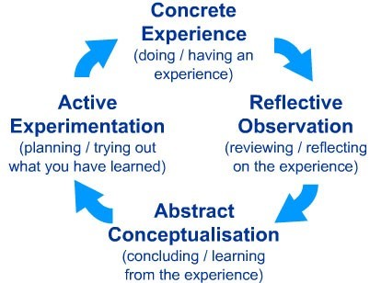

* Learning is a continuous process grounded in experience. Kolb (1984) emphasized that learning is a process that occurs from and is continually tested through experience.
* More specifically it is the difference between the expectations and experiences of the learner that facilitates the learning process.
* Not only is knowledge produced as trainers reinterpret previous experiences in light of new information, but it is expected that the trainers’ learning will continue as they continue to have and reflect on future experiences.
* Accordingly, in addition to the classroom exercises that occur during the course of the module, the facilitators are purposefully provided with a take home booklet of reference materials, including a list of self reflection questions they should pose during practices

**Example:** “Do my words or actions enhance the learning’s enjoyment in session?”

* Follow-up questions for after practices

**Example:** “How can I be an even better facilitator tomorrow than I was today?”

* These exercises are intended to encourage ongoing critical reflections, link these reflections back to the intended learning outcomes of the module, and promote continual learning.
* Consistent with the continuing nature of coach learning, it is recommended that a long term and ongoing evaluation scheme may be most appropriate

**Table 2:** Description of evaluation strategies using Kolb cycle stages

|  |  |  |  |  |
| --- | --- | --- | --- | --- |
| **Stages** | **Experiential learning concept** | **Self questioning** | **Reaction** | **Evaluation** |
| 1. Concrete experience | Action or activity  phase  (Facilitation/coaching/  guiding) ***Experiencing*** | What is it? | Feeling | New experience or existing experience feelings:  anxious/ease/comfortable /difficult/worry/calm/free /curious/nervous/agitated/ relaxed...? |
| 2. Reflective observation | Review to develop understanding   * exchanging reactions and observations * discussing patterns and dynamics ***Sharing and processing*** | What? | Watching/ observing | Peer observation and review, self observation and self assessment:  Why did I feel like this?  What did I do wrong?  What did I do right?  What should be done? |
| 3. Abstract conceptualisa tion | Developing real world  principles   * Identify positives and continue growing using them * Identify negatives and develop ideas to improve and overcome ***Analysing and***   ***Generalizing*** | So what? | Thinking | Good and clear explanation rather than practical opportunity. Exploring and analyzing models and theories basing on observations. Re/organize or creates other new models and theories.  “What can I do?” “What I have to improve?” |
| 4. Active | Select more | Now | Doing | Improvise, innovate, |
| experimentati on | appropriate techniques and develop improvements  - Planning  effective use of learning  ***Applying*** | what? |  | improve, apply to see what results then.    «Am I well prepared?  Yes, Let do it now!» |

# LU2 Reflect on the session in an interactive manner with the learners in line with CBET approach

Learning unit 2, guides in reflecting on the session in an interactive manner with the learners in line with CBET approach. It has three learning outcomes:



LO 2.1.: Review on Competence Based Education and Training (CBET) approach

LO 2.2.: Identify aspect of needing improvement

LO 2.3.: Fill up forms to reflect on the session facilitation process in line with

CBET approach

## LO 2.1.: Review on Competency Based Education and Training (CBET) approach

**Topic: Discussion on Competency based education and training (CBET)**

## approach

Description of CBET approach

* CBET approach differs from the traditional in the sense that those types of learning were mainly content/skills driven and teacher/trainer centered.
* While CBET is learner driven and aimed at achieving outcomes which are competencies.
* The trainer becomes more of a facilitator learning by stimulating creativity, self learning and critical thinking Outcomes become more important to the trainer than the written syllabus.

**Table 3:** Comparison between traditional and CBET approaches

|  |  |
| --- | --- |
| **Traditional approach/Content based**  **Training** | **CBET approach** |
| * Teacher centered * Passive learners * Exam driven * Rote-learning * Syllabus is content-based and broken down into subjects * Textbook bound and teacher centered * Syllabus is rigid and non-negotiable * Motivation dependent on personality of teacher * Emphasis on what the teacher hopes to achieve * Content placed into rigid time-frames * Curriculum development process not open to public comment * Teachers/trainers responsible for learning - motivated by personality of teacher * Emphasis what teacher hopes to achieve * Previous knowledge & experience in learning field ignored – Each time attends whole course | * Learner centered. Trainer is facilitator. * Active learners. Trainer constantly uses group work and teamwork * Learners are assessed on an ongoing basis * Different aspects of the learner’s abilities, such as creativity and critical thinking will also be assessed * An integration of knowledge, learning relevant and connected to real-life situations * Curricula seen as guides that allow trainers to be innovative and creative * Learners take responsibility for their learning. Trainees motivated by constant feedback and affirmation * Emphasis on outcomes – what the learner becomes and understands * Flexible time-frames allow learners to work at their own pace * Outcomes will be assessed in different ways and on an on-going basis * Trainees will not get marked just for remembering subject content |

Essential Outcomes of Competency Based Training

• Trainees should be able to demonstrate their ability to:

* Identify and solve problems by using creative and critical thinking
* Organize and manage themselves and their activities responsibly and effectively
* Communicate effectively – language skills and written presentation
* Use technology effectively and critically, showing responsibility

towards the environment and the health of others

* Show awareness of the importance of effective learning strategies, responsible citizenship, cultural sensitivity, entrepreneurial abilities.
* Regarding the positive impact of CBET on trainees, a trainer has to reflect on the facilitation to check whether s/he follows the learner centered and competency based approach.
* The curriculum gives learners a clear indication of what is expected of them in terms of performance, conditions and standard. Also, if appropriate, workplace and off-the-job training and assessment responsibilities should be identified.
* Delivery is flexible and learners can exercise initiative in the learning process. Learning materials used by providers indicate the degree to which program delivery is learner-centered.

## LO 2.2.: Identify aspect of needing improvement

Topic: Discussion on aspects of needing improvement

Good trainers are effective class managers and communicators who can adapt to a variety of learning styles and effectively facilitate a large percentage of the class. A trainer should recognize the aspect of needing improvement such as:

* Starting off each class by making attendance an instructional part of session.
* Avoiding the typical roll call of asking trainees whether they are there or not.
* Loving facilitation and check whether your trainees love learning.
* To make **learning engaging for trainees** you can integrate the following tactics and instantly improve your facilitation’s impact.
* **Technology-Driven Learning is More Fun**

Use  [Improvement Software](http://www.ultimatevocabulary.com/) that will help your trainees learning through fun games and interactive activities. Young people are more adept with technological skills, so by integrating software and social media into your facilitation routine you will instantly get your trainees’ attention – a prerequisite for advanced learning.

* **Give Responsibilities**

Trainees love being thought of as reliable, knowledgeable human beings. Boost this assertive self-image of your trainees by asking them to take up projects and initiatives of their own, in ways that illustrate what they learn in the classroom.

* **Make Facilitation Interesting**

Trainees get bored easily, so your goal is to be unexpectedly interesting.

Surprise your trainees with a session to discuss, to practice,…

* **Don’t Forget About Yourself**

Cultivate new skills, engage and be exposed to different kinds of social circles and experiences, and play with technology yourself in your free time. All of this will spruce up your own facilitation methods and multiply what you can give to your trainees.

a) Selection of facilitation techniques and learning methods basing on learning style of learners.

* The characteristics of trainees are identified and described in terms of how they affect their abilities to learn and how they perceive information.
* The learning style should be considered in the selection of learning resources and training techniques, in accordance with standard practice.**Types of learners:** VARK (Visual, Auditory, Reading and Writing, Kinesthetic) learning styles: How we perceive information. Here below there is a questionnaire exercise that can help a trainer to recognize what types of learners basing on their learning styles.

**The VARK Questionnaire (Version 7.1)**

**How Do I Learn Best?**

Choose the answer which best explains your

preference and circle the letter(s) next to it.

**Please circle more than one**

if a single answer does not match your perception.

Leave blank any question that does not apply.

1

. You are helping someone who wants to go to your airport, town centre or railway

station. You would:

a. go with her.

b. tell her the directions.

c. write down the directions.

d. draw, or give her a map.

:

. You are not sure whether a word should be spelled `dependent' or `dependant'. You would

2

a. see the words in your mind and choose

by the way they look.

b. think about how each word sounds and choose one.

c. find it in a dictionary.

d. write both words on paper and choose one.

:

3

. You are planning a holiday for a group. You want some feedback from them about the plan. You would

a. des

cribe some of the highlights.

b. use a map or website to show them the places.

c. give them a copy of the printed itinerary.

d. phone, text or email them.

. You are going to cook something as a special treat for your family. You would

:

4

a. cook something

you know without the need for instructions.

b. ask friends for suggestions.

c. look through the cookbook for ideas from the pictures.

d. use a cookbook where you know there is a good recipe.

5

. A group of tourists want to learn about the parks or wildlife

reserves in your area. You would:

a. talk about, or arrange a talk for them about parks or wildlife reserves.

b. show them internet pictures, photographs or picture books.

c. take them to a park or wildlife reserve and walk with them.

d. give them a book o

r pamphlets about the parks or wildlife reserves.

6

. You are about to purchase a digital camera or mobile phone. Ot

her than price, what would most

influence your decision?

a. Trying or testing it.

b. Reading the details about its features.

c. It is a modern

design and looks good.

d. The salesperson telling me about its features.

7

. Remember a time when you learned how to do something new. Try to avoid choosing a physical

skill, eg. riding a bike. You learned best by:

a. watching a demonstration.

b. listening

to somebody explaining it and asking questions.

c. diagrams and charts

-

visual clues.

d. written instructions

–

e.g. a manual or textbook.

8

. You have a problem with your heart. You would prefer that the doctor

:

a. gave you a something to read to explain

what was wrong.

b. used a plastic model to show what was wrong.

c. described what was wrong.

d. showed you a diagram of what was wrong.

9

. You want to learn a new program, skill or game on a computer. You would

:

a. read the written instructions that came

with the program.

b. talk with people who know about the program.

c. use the controls or keyboard.

d. follow the diagrams in the book that came with it.

10

. I like websites that have

:

a. things I can click on, shift or try.

b. interesting design and visual

features.

c. interesting written descriptions, lists and explanations.

d. audio channels where I can hear music, radio programs or interviews.

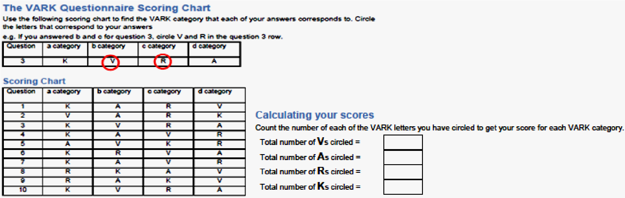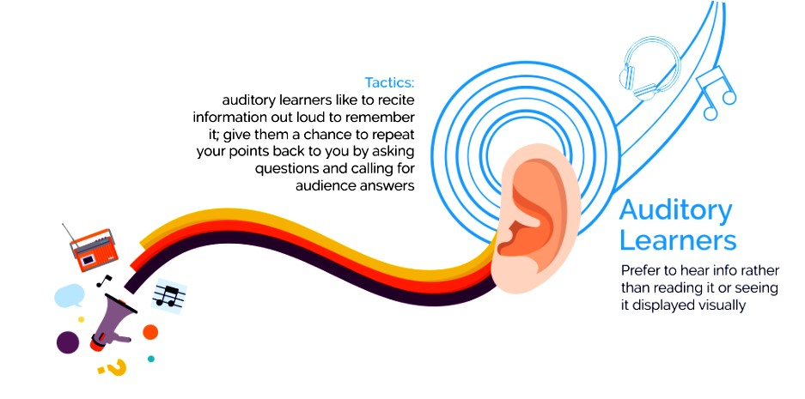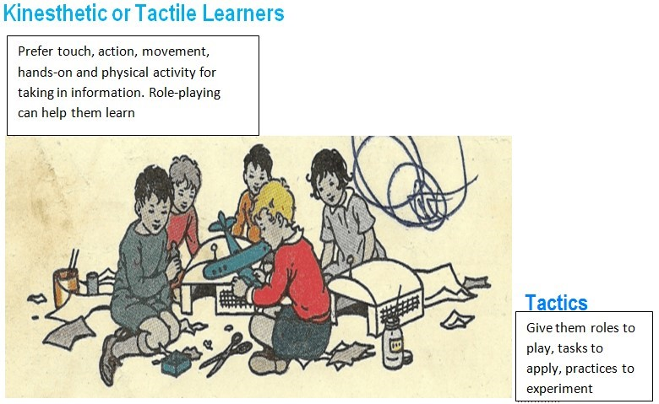

* Observe trainees during the session for your own perception of their reception.
* If participants do not react favorably, they probably will not be motivated to learn and they are not comfortable

## LO 2.3.: Fill up forms to reflect on the session facilitation process in line with CBET approach

Topic: Completion of forms to reflect on the session facilitation process

To reflect on session facilitation [makes the difference between event success or failure. Learn how to be an effective facilitator, and find out how to develop the skills for the improvement of future sessions.](https://www.mindtools.com/pages/article/RoleofAFacilitator.htm)

Adapt learning materials to suit the trainees and learning session

* Adapting a visual and a text based existing resource to support session outcomes.
* Complying with copyright laws in adapting and developing resources to support learning

a) Adaptation of a text-based learning resource form Element to consider:

* The original text based resource
* The adapted text based learning resource
* Overview of the adaptations made

|  |  |  |
| --- | --- | --- |
| **Text based / written material** | | |
| The original text based resource | | |
| The adapted text based learning resource | | |
|  | |  |
| Overview of the adaptations made | |  |
| **Original form** | **Adapted form** | **Why I changed** |
|  |  |  |
|  |  |  |
|  |  |  |
|  |  |  |
| **How copyright was observed** | |  |
|  | |  |

**Justification for the self-developed text based learning resource**

Justification for self-developed learning resource

Enter information in space provided below:

|  |
| --- |
| Session topic:    Session Objective(s): |
| Name of learning resource: |
| Rationale for developing the learning resource/how it will be used in the session: |
| Describe stages in the development of the learning resource: |
| Limitations of the learning resource I have developed: |
| How copyright was observed |

**A checklist form for the text based resource**

Learning resource:

Name: Date:

CHECKLIST FOR APPROPRIATENESS OF PRINT BASED MATERIALS (Text / graphics)

Type of written material

NB Depending on the type of written material not ALL criteria in the list below might apply. If not applicable write NA (it still might require justification why you say NA)

|  |  |  |
| --- | --- | --- |
| *Content – The written material* | *YES / NO* | *Justification*  *Comments* |
| 1. relates clearly to the learning outcomes /PCs of a unit |  |  |
| 2. contains information that is not readily available to the learner |  |  |
| 3. gives the information in a logical order |  |  |
| 4. is factual correct (does NOT contain any content error) |  |  |
| 5. is current |  |  |
| 6. is unbiased (opposing views are honestly presented) |  |  |
| 7. addresses the interest of the learners |  |  |
| 8. caters for learners with different abilities |  |  |
| 9. includes clear instructions for any test questions, task or procedure to be done |  |  |
| 10. includes all necessary steps in procedures and instructions |  |  |
| 11. includes safety precautions for all dangerous or difficult procedural steps |  |  |
| 12. requires active involvement of the learner (learners have to actively interact with the resource) |  |  |
| 13. motivates learners – attracts their attention and stimulates their learning |  |  |
| 14. holds the attention of the learners |  |  |

|  |  |  |
| --- | --- | --- |
| *Style – The written material* | *YES / NO* | *Justification*  *Comments* |
| 1. uses simple, clear language throughout |  |  |
| 2. explains any trade or technical terms |  |  |
| 3. subdivides long handouts with headings to help guide the learner (short paragraphs) |  |  |
| 4. leaves plenty of white space so that the type is not overwhelming to read |  |  |
| 5. leaves plenty of white space where learners can write notes (wide margins) |  |  |
| 6. includes an overview before each set of procedures |  |  |
| 7. gives procedural steps in the order they will be performed |  |  |
| 8. places safety cautions immediately before the action(s) they refer to |  |  |
| 9. divides long, complex procedures into groupings of between five and nine steps |  |  |
| 10. places graphics close to the text it is supporting |  |  |
| 11. uses non-discriminatory language |  |  |
| 12. has readability index corresponding to level of learners |  |  |
| 13. uses short sentences (not more than about 20 words; one idea per sentence) |  |  |
| 14. has introduction – text – summary lay out |  |  |
| 15. makes appropriate use of images / colour |  |  |
| 16. does not violate copy rights laws |  |  |
| 17. makes appropriate reference to resources used |  |  |
| 18. does include space for learners’ name / ID |  |  |
| 19. does include space for the date |  |  |
| 20. does include space for feedback by facilitator |  |  |
| 21. cites appropriate reference materials for learners to follow up after the session |  |  |

|  |  |  |
| --- | --- | --- |
| *Graphics – The written material* | *YES / NO* | *Justification*  *Comments* |
| 1. contains graphics that illustrates the topic clearly and adds to the text |  |  |
| 2. has appropriate labels / headings / titles for graphics included |  |  |
| 3. uses graphics to explain difficult or complicated procedural steps |  |  |
| 4. uses graphics to attract attention of learners |  |  |
| 5. does NOT include graphics but should have to enhance learning |  |  |
| *Educational criteria: The written material* | *YES / NO* | *Justification*  *Comments* |
| 1. can be used by ALL learners |  |  |
| 2. is justifiable for its use in the session in terms of cost in time, money and effort invested in its production |  |  |
| 3. is easy to use by the learner / facilitator |  |  |
| 4. is durable (has acceptable life span) |  |  |
| 5. is flexible in use (can be used in a variety of ways / easy adaptable to a new situation) |  |  |
| 6. is environmentally friendly |  |  |
| 7. is ESSENTIAL – learning outcome could not have been effectively attained without the use of the resource |  |  |

b) Adaptation of a visual learning resource form Element to consider:

* The original visual resource
* The adapted visual learning resource
* Overview of the adaptations made

|  |  |  |
| --- | --- | --- |
| **Text based / written material** | |  |
| The original visual resource | |  |
| The adapted visual learning resource | |  |
| Overview of the adaptations made | |  |
| **Original form** | **Adapted form** | **Why I changed** |
|  |  |  |
|  |  |  |
|  |  |  |
|  |  |  |
|  |  |  |
| **How copyright was observed** | | |
|  | | |

**A checklist form for the visual resource**

EDUCATIONAL CRITERIA THAT ALL LEARNING MATERIALS SHOULD ADHERE TO

Learning resource:

Name Date

|  |  |  |  |
| --- | --- | --- | --- |
|  | **CRITERIA** | YES/NO | COMMENTS / JUSTIFICATION |
| • | Relevant to learning objectives/ PCs of the training session |  |  |
| • | Improve learners’ understanding / learning [substantially **ADDS** to enhance the learning process] |  |  |
| • | Appropriate for **ALL** learners. No learner is disadvantage by use of material |  |  |
| • | Can be justified in terms of cost in time, money and effort |  |  |
| • | Flexible in use. Can easily be adapted to specific situation. |  |  |
| • | Does not require high technical skills of facilitator when used |  |  |
| • | Can be reused (durability of the material) |  |  |
| • | High involvement of learners / activity based(interaction with the materials) / promoting strongly a learner-centred approach |  |  |
| • | Provide experience that could not be easily obtained otherwise |  |  |
| • | Current, up-to-date content |  |  |
| • | Unbiased content. Provides alternative ideas  / views |  |  |
| • | Content error free / factually correct |  |  |

|  |  |  |  |
| --- | --- | --- | --- |
|  | **CRITERIA** | YES/NO | COMMENTS / JUSTIFICATION |
| • | Non-discriminatory / non-offensive to any user |  |  |
| • | Motivating to learners / holding attention of learners |  |  |
| • | Appropriate for the group size |  |  |
| • | Appropriate for the facilities (room facilities  / physical environment) |  |  |
| • | Environmental friendly |  |  |
| • | Safe to use (not forming a health hazard) |  |  |
| • | Not violating copy right laws |  |  |
| • | Appropriate for target group’s characteristics o Needs   * Motivation for learning o Interests o Level of competence/achievement o Age o Gender o Learning style o Learning preference o Level of prior knowledge, understanding, skills and experiences * Language, literacy, numeracy needs o Communication skills o Cultural / ethnic background |  |  |
| • | Artistically correct (lay out, font size, use of colour, use of images, use of sound, use of animation) |  |  |
| • | Essential (Learning required could not have been effectively conveyed without the use of the learning resource) |  |  |
| • | Availability o Readily available o Needs prior planning o Needs special arrangements |  |  |
| • | Accessibility  o Easy to access o Prior arrangements to be made |  |  |

**Justification for the self-developed visual learning resource**

*Justification for self-developed learning resource*

Enter information in space provided below:

|  |
| --- |
| Session topic:    Session Objective(s): |
| Name of learning resource: |
| Rationale for developing the learning resource/how it will be used in the session: |
| Describe stages in the development of the learning resource: |
| Limitations of the learning resource I have developed: |
| How copyright was observed |

Facilitate CBT learning sessions Element to consider:

* Establish and maintain a positive learning environment
* Engage trainees in purposeful and appropriate learning experiences ✓ Provide effective learning support

Creating an environment conducive to effective learning



Maintaining an environment conducive to effective learning

Facilitation to groups using presentation, demonstration and learning activities

* + Employing at least once each of the following learning resources:

o PowerPoint slides o Computer based activity o Worksheet o Formative assessment instrument

* + Demonstrating skills in providing guidance and support to trainees during learning sessions
* Session plan of the session
* Learning resources used in the session
* Self-evaluation report (including data collection tools)

1. Session observation checklist form (It can be completed by colleagues or oneself)

|  |  |  |
| --- | --- | --- |
| **Criteria** | **Comments /What was observed** | **Achieved Yes/No** |
| **THE VENUE** |  |  |
| **The room:** |  |  |
| Conducive to learning (temperature, ventilation, light) |  |  |
| Safe for learning – clean, access to emergency exit, no tripping hazards, safely connected electric devices |  |  |
| **Furniture** |  |  |
| Appropriate arranged for the session (sufficient space for movement) |  |  |
| Adequate for trainees and activities |  |  |
| **Equipment** |  |  |
| Easily available |  |  |
| Adequate for the trainees |  |  |
| In working order / set up ready for use |  |  |
| **CONDUCT THE TRAINING** |  |  |
| **Introduction** |  |  |
| Motivating & gaining attention: ice breaker and/or recap of previous session |  |  |
| Topic is stated/announced |  |  |
| Objectives are explained |  |  |

|  |  |  |
| --- | --- | --- |
| **Criteria** | **Comments /What was observed** | **Achieved Yes/No** |
| Learners are put at ease / open friendly attitude |  |  |
| Ground rules, if applicable, are negotiated, specified, recalled |  |  |
| **Development** | | |
| ***Content Facilitation*** |  |  |
| Session Plan is followed (flexible) |  |  |
| Good logical sequencing of content |  |  |
| Content linked to trainees experiences / skills / knowledge; world of work |  |  |
| Appropriate pace is used |  |  |
| Information is presented clearly, accurately |  |  |
| Information is presented in more than one mode: oral, written, visual |  |  |
| ***Use of Methods*** | | |
| A range of methods are used e.g. trainer guided learning, experiential learning, cooperative learning, individualized learning |  |  |
| Learners are involved through activities such as role plays, group work, interactive worksheets |  |  |
| Tasks are clearly explained |  |  |
| Activities are timed and monitored |  |  |
| Feedback is obtained from learners on progress / outcomes produced |  |  |
| Opportunities for formative assessment are built into the session |  |  |
| Plenary session is conducted |  |  |
| * Secretary role / receive information from trainees * Classifying the outcomes with trainees * Producing agreed group response / outcome * Expert view on whole group outcome |  |  |
| ***Use of Learning Resources/Materials*** |  |  |
| Available in accordance with plan |  |  |
| Effectively utilized, competently handled |  |  |
| ***Maintaining positive learning environment*** | | |
| Learners are encouraged to participate in session |  |  |
| Learner questions are handled effectively |  |  |
| Learners’ ideas/suggestions handled sensitively |  |  |
| Learners are given prompt constructive and timely feedback |  |  |
| Disruptions such as inappropriate language and/or behavior is corrected promptly |  |  |
| Provides support for individuals |  |  |
| **Closure of Session** | | |
| Learners are assessed to check achievement of objectives |  |  |
| Written assessment is timed |  |  |
| Main learning points is summarized (review session objectives) |  |  |
| Links to next session established |  |  |
| Session is facilitated to the plan and on time |  |  |

|  |  |  |
| --- | --- | --- |
| **Criteria** | **Comments /What was observed** | **Achieved Yes/No** |
| **Facilitator’s Communication Skills** |  |  |
| Voice is audible and clear |  |  |
| Body language is appropriate |  |  |
| Appropriate movement and use of room space |  |  |
| Language is at appropriate level |  |  |
| Reacts appropriate to none verbal cues from trainees |  |  |
| Overall Comments (if any): |  |  |

1. Self-evaluation report (To be completed immediately after your session)

|  |  |
| --- | --- |
| Strengths of my session. What went well? What I am happy about? | 1  2  3  4 |
| Weaknesses of my session.  What did not go as I expected? What did not work out as planned? | 1  2. 3.  4. |
| What I think are the reasons for the shortcomings I listed above? | 1. 2. 3.  4. |

**Evaluation report and Action plan form**

(To be completed after analyzing the feedback data and summarizing)

|  |  |  |  |  |
| --- | --- | --- | --- | --- |
| **Feedback from**  ***Trainees /***  ***Colleagues* / *Self*** | **Aspects that went well** |  | **Aspect needing improvement** | **Suggested improvements**  **What I plan to do / to implement** |
| What the  learners said | 1  2  3  4  5  6  7 | 1  2  3  4  5  6  7 |  |  |
| What my  assessors said | 1. 2  3  4  5  6  7 | 1. 2  3  4  5  6  7 |  |  |
| What I wrote in my selfevaluation report | 1. 2  3  4  5  6  7 | 1. 2  3  4  5  6  7 |  |  |

1. Observation checklist form of carrying out assessment activities (To be completed while the assessment process)

|  |  |  |
| --- | --- | --- |
| **Criteria** | **Comments** | **Yes/No** |
| Location chosen for the assessment suits the content |  |  |
| The location is prepared well in advance of the assessment |  |  |
| The environment meets health and safety requirements |  |  |
| Prior to assessment, effort is made to reduce anxiety in trainee by:   * Stating expectations * Checking readiness * Explaining re-assessment * Stating appeal procedure |  |  |
| The assessment matched the selected assessment materials |  |  |
| The assessment matched the agreed assessment arrangements |  |  |
| All resources required for the assessment were available |  |  |
| The evidence produced by the candidate is checked for:   * Validity * Authenticity * Sufficiency |  |  |
| The assessment decision is consistent (with other assessors) |  |  |
| Feedback to trainee was prompt and direct |  |  |
| Feedback focused on performance (strengths and weaknesses) |  |  |
| Interaction is kept warm and professional throughout |  |  |

# LU3 Improve the learning process based on the evaluation results.

Learning unit 3 leads a person on how to improve the learning process based on the evaluation results. It has three learning outcomes:



## LO 3.1.: Identify strategies of improving the learning process

LO 3.2.: Engage in professional development

LO 3.3.: Set an improvement progress map

**LO 3.1.: Identify strategies of improving the learning process**

Topic: Discussing Strategies to improve the session facilitation

Taking trainees from a rather superficial knowledge structure to a richer, more meaningful knowledge structure requires an instructor who truly understands the learning process and then works to create the optimal climate for learning. The 50 strategies below should help a facilitator to improve in the following areas:

* Create a welcoming atmosphere for trainees
* Set a positive tone for learning;
* Engage the trainees actively;
* Provide support for trainees, and show them where they can find support;
* Encourage trainees to keep up and do well
* Use appropriate learning resources effectively
* Use of time efficiently and effectively

Strategies are:

1. Come a few minutes early and engage trainees in conversation as they enter the classroom.
2. Introduce yourself and your facilitation assistants by slide, short presentation, or self introduction.
3. Start each class period with some kind of recap, ice-breaker, or check-in.
4. Share your philosophy of facilitation with your trainees.
5. Let your trainees see the enthusiasm you have for your subject and your love of learning.
6. Make an effort to learn your trainees' names and get to know them personally.
7. Encourage your trainees to find a "buddy" with whom they can exchange addresses and keep in touch about assignments and coursework.
8. Form small groups for getting acquainted; mix and form new groups several times.
9. Include content, not just syllabus and "housekeeping" details, from the very first day of class.
10. Take attendance.
11. Explain why this course is necessary, important, and exciting; tell about your current research interests.
12. Tell trainees how much time they will need to learn for the course.
13. Explain how to study for the kind of assessments you give, and what the expectations are for grading.
14. Move around the room to engage trainees and to discourage behavior such as whispering, distracting others or chatting.
15. Make eye contact with trainees. Choose trainees, preferably by name, and alert him or her to be ready to answer the next question.
16. Start facilitation with a puzzle, cross words, question, paradox, picture, or cartoon on slide or transparency to focus on the day's topic.
17. Stage a figurative "break" about twenty minutes into the period: tell a story, invite trainees to put down pens and pencils, refer to a current event.
18. Use variety in methods of presentation every class meeting: facilitation, small group discussion, debate. Also, use multiple media during the class: overhead, videotape, audiotape, models, and/or sample material.
19. Stage a change your mind debate, with trainees moving to different parts of the classroom to signal change in opinion during the discussion.
20. Conduct a role play to make a point or to present issues.
21. Give trainees an opportunity to voice opinions about the subject matter.
22. Give your trainees time to answer questions; count slowly (and silently) to 10 after you pose a question before you rephrase it.
23. Invite trainees to ask questions and wait for other trainees to respond.
24. Ask follow up questions to trainees’ responses and comments.
25. Make collaborative assignments for several trainees to work on together.
26. Have trainees apply the course subject matter to solve real problems.
27. Have trainees write questions on index cards to be collected and answered the next class period (if at all possible).
28. Use the Clicker to engage trainees and gather information on whether they understand course content.
29. Set high expectations and be explicit about what they are.
30. Begin the class period with a quick summary about "last time"; end each class with a quick forecast of "next time" the class meets.
31. Elicit trainee’s questions and concerns at the beginning of the class and list these on the board to be answered during the hour.
32. Have trainees to write down what they think the important issues or key points on the day's facilitation will be (or were).
33. Give a pretest (ungraded or self graded) on the day's topic.
34. Try to incorporate trainees reading, writing, listening, and speaking in each class period.
35. Make learning goals explicit for each assignment; explain clearly what trainees are to do and how it fits into the course as a whole (and at the very least, make sure all of this is explicit in your mind).
36. Take a few minutes to allow trainees to free write on the day's reading or to explain it to one another.
37. Give trainees plenty of opportunity for practice before a major test.
38. Give a test early and return it graded by the next class meeting if at all possible.
39. Collect trainees' current contacts (particularly cell phone) numbers and let them know that you may need to reach them.
40. Be aware of trainees who are frequently absent. Call trainees to express your concern.
41. Diagnose the trainees' prerequisite learning by a questionnaire or pretest and give them the feedback as soon as possible.
42. Repeat yourself trainees should hear, read, or see key material at least three times.
43. Provide structure for visually oriented trainees by posting the day's "menu" on board, overhead, or screen.
44. Use multiple examples to illustrate key points and important concepts.
45. Be available to trainees before or after class and join their conversation about course topics.
46. Use community resources in your facilitation: plays, concerts, government agencies, businesses, professional contacts, or the outdoors.
47. Solicit suggestions from trainees for outside resources and guest speakers on course topics.
48. Tell trainees when you will check their suggestion box (two or three times per day, perhaps less?) and your timeframe for returning trainees messages.
49. Keep a course diary brief note on a calendar or a copy of the course syllabus about what worked well on a particular day, so you can plan to do the same thing next time.
50. Gather trainees’ feedback in the first few weeks of the semester to improve facilitation and learning.

Everything you do as facilitator, what you say, how you use the room and other learning resources, your nonverbal communications- either helps encourage participation or control the learning process. Learning to love facilitating is about understanding your role and practicing your skills. When you do you will enjoy the balancing and improve the learning process.

## LO 3.2.: Engage in continuing professional development (CPD)

Topic: Description of continuing professional development in learning process

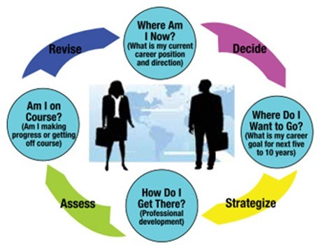

**Definition**

* CPD stands for Continuing Professional Development.
* It refers to the process of tracking and documenting the skills, knowledge and experience that you gain both formally and informally as you work, beyond any initial training.
* It's a record of what you experience, learn and then apply.
* The term is generally used to mean a portfolio documenting your development as a professional.

**Importance of engaging in CPD in session facilitation process** A CPD help:

* To reflect, review and document the facilitation and learning
* To develop and update the professional knowledge, skills and attitudes.
* To provide an overview of the professional development to date
* To remind the achievements and how far it progresses
* To direct the career and helps to keep the eye on the goals
* To uncover gaps in the skills and capabilities
* To open up further development needs
* To help own career development or a possible career change.

**Engagement in CPD**

* Keep a learning log and record your thoughts in whatever way suits you best. You may find it helpful to write things down in detail, for example, or to make notes on insights and learning points.
* The process of writing makes you think about your experiences at the time, and makes planning and reflection much easier. You can't review your experiences without recording them, however good your memory is.

Answering the following questions may help you to get started:

***Where am I now?***

(Assess where you are now)

Review and reflect on any learning experiences over the previous year or over the past three months. Write your thoughts down about what you learned, what insights it gave you and what you might have done differently. Include both formal training events and informal learning, such as:

* Learning from colleagues or shared learning from networking
* Reading about new technologies, new methods of working, legislative changes
* Shadowing or assisting an experienced colleague
* Insights and learning points from coaching and mentoring
* Reflections, insights and learning points from taking on a new responsibility
* Organizational or role change
* Temporary job swaps within the department/organization
* Deputizing or covering for colleagues
* Insights and lessons learned from mistakes
* Lessons learned from critical incidents or events

Make a note of any outcomes of each learning experience and what difference it has made to you, your colleagues, your students (if relevant) or your employer.

***Where do I want to be?***

(Identify what professional skills you need to work on and what your specific career goals)

* Write down your overall career goals - where you want to be in two, five and 10 years' time.
* Then write down no more than three specific and achievable shorter term objectives, including the dates by which you want to achieve them.

***What do I have to do to get there?*** (Develop a timeline for accomplishing your specific targets and goals and choose how you will accomplish them)

* Looking at your overall career goals, make a note of what you need to do to achieve them. This could include further training, job or role progression or changes in direction.
* For shorter term objectives, include the first step - what you can do today or tomorrow. For example, having a chat with your manager about a new responsibility or finding out a new technology from a colleague who has experience of it.

***When should I review progress?***

(Measure your progress)

* This step is essential! You'll need to set a date in advance for review of the objectives you've set yourself.
* You can either do this from one review to the next or decide to review regularly - once every three, six or 12 months.
* Put it in your diary and do it!
* Measuring your progress will help you know if you are hitting your ‘check lists’, meeting your targets and are on track for reaching your goals. You may need to set more manageable steps, or make new targets, or even set new goals.
* Remember that plans change and, as you go through your career, your goals will progress with you. Learning is a lifelong process, and it’s important to continue your professional development to ensure career success.

## LO 3.3.: Set an improvement progress map

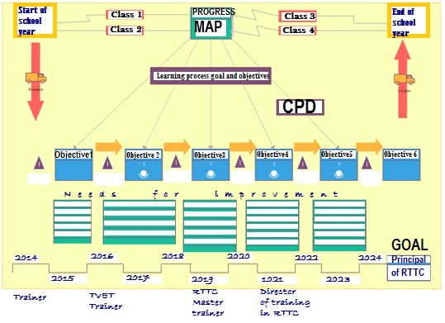

Topic: Setting improvement progress map

* If you are in the position of taking up CPD now, this system has been designed so that you can follow the guidelines and get your own portfolio started quickly and easily.
* In addition, it is intended to be flexible so that you can add your own forms, records and supporting documentation as you progress. The end result should be a comprehensive account of your professional development and progress.

***There are four stages in the process:***

**1. Setting your goals and objectives**

* Identify goals you want to achieve. These may be short, medium or long term goals. Including personal goals with professional goals can be a useful reminder that no one works in isolation and that personal and professional achievements are often interrelated.
* People change over time and it is therefore to be expected that your goals may change also, particularly the longer term goals which may therefore be less specific than those identified for short term action.
* The template below will help to illustrate goals and objectives

**Professional goals guidance form**

Name:……………………………………………………………………………….

|  |  |  |  |  |  |  |
| --- | --- | --- | --- | --- | --- | --- |
| No | Date identified | Goal | Time scale Short/  Medium/  Long | Projected completion | Actual completion | Comment/  observation |
|  |  |  |  |  |  |  |
|  |  |  |  |  |  |  |
|  |  |  |  |  |  |  |
|  |  |  |  |  |  |  |
|  |  |  |  |  |  |  |
|  |  |  |  |  |  |  |
|  |  |  |  |  |  |  |

**2. Carrying out a personal needs analysis**

* This process involves you identifying your present knowledge, skill and abilities and strengths and weaknesses.
* Begin by listing the identifiable qualifications or competencies and then move on to those personal qualities.

Describing the skills required. The second step is to describe existing skills, before identifying the gaps which need to be met.

* The template below will help to illustrate your personal needs

Personal needs analysis form for next facilitation improvement

Name:

|  |  |  |
| --- | --- | --- |
| Skills required | Exiting skills | Identified gaps |
|  |  |  |
|  |  |  |
|  |  |  |
|  |  |  |

**3. Identifying your needs**

* It is important when you are setting the skills required, that the level is properly identified. Determining the gaps with existing skills following the process through, it should now be clear what is available and what is required.
* The final stage is to produce a list of your development needs which fill these gaps.
* The list of development needs is the true measure of your CPD needs.
* The statements should specify exactly what must be achieved and it is important to record them in the progress map. it is important that you have a means of listing your development needs.
* The four stage process is one which you must undertake individually and can be a very private exercise.

**4. Regular periodic reviews**

* On a regular basis, your personal progress map needs to be reviewed so that it remains current and of value. You decide how frequent this review needs to be, but a frequency of not less than one year is recommended. Check that your goals are still relevant and sufficient and ensure that your progress towards your identified goals is on track.

* You might like to do this using the “periodic review” prompt sheet contained in this notes. That sheet contains a list of key points that can assist you in forming your own self questionnaire, which you can adapt further for your own needs by adding more personally relevant questions as necessary. It is wise to record the results of this review and refer to it frequently in order to keep on track.

* You might also like to use that page when you put together your personal CPD plan for the first time. In addition, review the CPD activities in which you participate.

* Reflect on the value of the activity to you personally and whether it is of use to you in your current role, or is of value in developing your potential for future roles. Reviewing each activity is a comparative process which examines the objectives set, either by the individual or the CPD provider, with what has been achieved and carrying out the basic analysis:

* By recording information regularly, you can maintain a chronological account of progression. It’s always important to set an aim or goal for each role as this can help to refresh the memory, stop complacency and help to prevent getting “in a dull routine”

# Reference

1. Thomas A. Angelo and K. Patricia Cross (1993). *Classroom Assessment Techniques*, 2nd ed. San Francisco: Jossey-Bass, 1993.
2. Willkinson, Michael. “*Facilitation Excellence: The Seven Separators: What separates top facilitators from good ones?*” at: [http://www.leadstrat.com/library/articles.asp.](http://www.leadstrat.com/library/articles.asp) July 2008.
3. Tarmiz, Halbana. Jan de Vreede, Gert. Sigurs, Ilze. 2006. “*Identifying Challenges for Facilitation in Communities of Practice*.” Proceedings of the 39th Hawaii International Conference on System Sciences
4. Good Group Decisions, Inc. 2007. “**Characteristics of Good Meeting Facilitators**.” Good Group Decisions, Inc., 98 Maine Street, Brunswick, ME 04011. Accessed at: [www.GoodGroupDecisions.com.](http://www.goodgroupdecisions.com/) July 2008
5. Willkinson, Michael. “**Target Characteristics of Facilitator Candidates.**” available at: [http://www.leadstrat.com/library/articles.asp.](http://www.leadstrat.com/library/articles.asp) July 2008.
6. “*Basic Facilitation Skills*.” May 2002. The Human Leadership and Development Division of the American Society for Quality, The Association for Quality and Participation, and The International Association of Facilitators.
7. “*Community of Practice Design Guide A Step-by-Step Guide for Creating Collaborative Communities of Practice*” Copyright © 2004, iCohere, Inc.

1. <https://www.mindtools.com/pages/article/RoleofAFacilitator.htm>
2. [http://education.gov.gy/web/index.php/teachers/tips-for-teaching/item/1343how-to-improve-teaching-in-the-classroom](http://education.gov.gy/web/index.php/teachers/tips-for-teaching/item/1343-how-to-improve-teaching-in-the-classroom)
3. [https://www.discprofiles.com/blog/2015/.../10-ways-to-improve-yourfacilitation-skill*.*](https://www.discprofiles.com/blog/2015/.../10-ways-to-improve-your-facilitation-skill)*..*
4. **Original Articles**
5. [Kathleen M. Armour &](https://www.tandfonline.com/author/Armour%2C+Kathleen+M) [Martin R. Yelling](https://www.tandfonline.com/author/Yelling%2C+Martin+R) *Continuing professional development for experienced physical education teachers: towards effective provision*. Pages 95-114 | Published online: 13 Oct 2010

<https://doi.org/10.1080/1357332042000175836>

1. [Kathleen M. Armour](https://www.tandfonline.com/author/Armour%2C+Kathleen+M) [“*Teachers' continuing professional development in primary physical education: lessons from present and past to inform the future*”](https://www.tandfonline.com/doi/full/10.1080/1740898042000208098?src=recsys)et al.Physical Education & Sport Pedagogy Volume 9, 2004 - Issue

1**Published online:** 31 Jan 2007